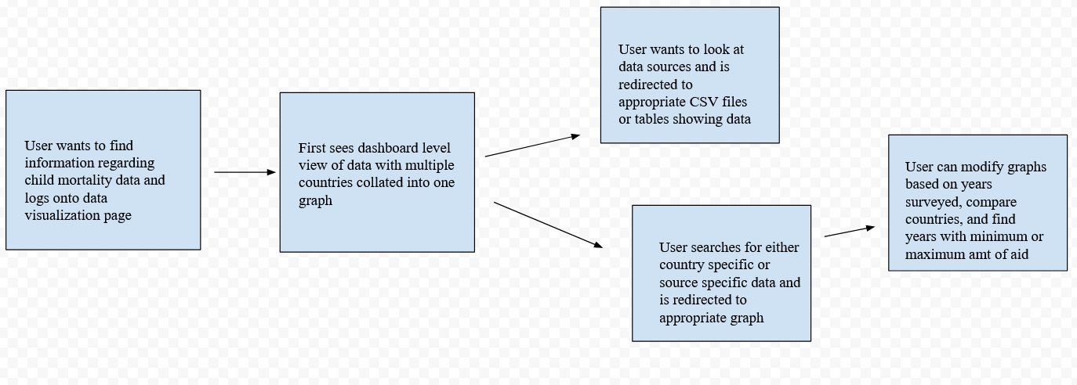

**Ask An Expert**

**What if the data suggests that aid distribution has a delayed impact on child mortality rates?**

We’ll include annotations on country specific information to indicate where it’s most likely that aid given in one year had an impact in subsequent years.

**What if there are multiple sources of aid?**

The aid given to specific countries will be collated as a default with options to separate out the funding by source.

**What about countries that don’t see any improvement in child mortality rates?**

This will be analyzed and posted in a different portion of the website, with charts showing that the death rates did not improve even after prolonged years of funding.

**Scenarios/User Stories**

Bill Shafer: As a policy maker, I want to be able to access the worst affected countries with the most persistent rates of infant deaths, especially those amongst countries that have consistently received aid, so I can evaluate which areas might need a different approach in giving.

Mandy Bright: As a student, I want to be able to look at the delays between aid distribution and differences in child mortality rates so I can better utilize the data for a paper on the usefulness of international aid

Syrus Till: As a retiree interested in seeking out more information on aid and national health, I want to be able to look at country specific information but in a way that’s intuitive for me.

**Feature List**

* List of aid sources with descriptions of private/public funding, what countries received what aid, and what earmarks existed if any
* List of countries involved in the project with annotations if any countries left or were added to the data mid way through
* Country-specific graphs with multiple views of aid money distributed over time with child mortality rate superimposed over it
* Annotations for each country indicating what correlations existed, if any, and what kind of delay between aid received